Understanding Non-Arthritic Hip Problems
Over the past decade, our understanding of and ability to treat non-arthritic hip problems has grown exponentially. With the advent of advanced arthroscopic technology and techniques, we have been able to return people to their sports and lives in ways we couldn’t have imagined in years past. Additionally, we have developed a much clearer understanding of what the pain generators are in and around the hip.
What is the Labrum?
Why Does the Labrum Tear?
Understanding FAI
What’s the Problem with FAI?
What type of symptoms do people with hip labral tears and FAI have?
What is the treatment of FAI and labral tears?
Surgical Treatment: Dr. Wolff’s philosophy
Labral Tears: How to treat
How to Treat FAI (Hip Impingement)
What is the Hip Capsule?
Problems with the Hip Capsule
How to Treat Hip Capsule Problems
What to do when the labrum is deficient
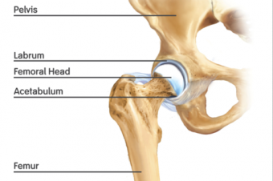What is the Labrum?
Lately much attention has been focused on the labrum. At an anatomic level, the labrum is a fibrocartilaginous ring that encircles the superior 80% of the acetabulum (hip socket). Its job is to extend the depth of the hip socket and impart stability to the hip by deepening the hip socket and forming a fluid seal to manage the joint fluid within the hip. The reason it’s been getting a lot of attention of late is that when it tears it hurts and can lead to further instability and breakdown of the rest of the hip. The good thing is that we now have excellent and proven techniques which--when done properly--can repair or reconstruct the labrum in an anatomically correct way which will restore the painless function of the labrum and the hip itself.
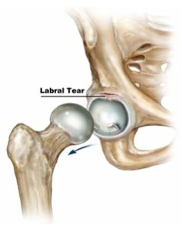Why Does the Labrum Tear?
About three quarters of all patients with symptomatic hip labral tears will complain of an insidious onset of pain—that is, they don’t recall a specific injury that caused the hip pain. The pain just started one day. In approximately 90% of cases, there is an underlying abnormality of the bony structure of the hip that predisposes the hip to develop labral tears. By far, the most common underlying problem with the structure of the bone is what’s called Femoroacetabular Impingement (FAI).
Understanding FAI
While the hip is mechanically a complex joint that moves in multiple planes at the same time, and many factors can affect the ways in which an individual hip moves, the concept of impingement can be easily explained by simplifying the joint into one plane of motion and two types of impingement. The two types of impingement are called “cam” and “pincer”. If you imagine the hip as a simple ball and socket joint, the cam type impingement comes from an abnormality of the ball; the pincer type comes from an abnormality of the socket. This quick video provides a nice explanation of the concept. (https://www.youtube.com/watch?v=LcmjrKWotFw)
What’s the Problem with FAI?
There are many people walking around who have FAI and don’t know it. There is no reason to correct FAI if it is not causing symptoms. However, symptomatic FAI and labral tears, if unresponsive to non-surgical treatment, can cause persistent pain and disability and can lead to progressive damage to the hip joint.
What type of symptoms do people with hip labral tears and FAI have?
The symptoms are variable. The most common pain is deep in the groin. This is often accompanied by pain elsewhere more towards the surface (i.e., the side of the hip, the top of the hamstrings, the lower back, the SI joint, the lower abdominal wall, the adductor muscles, the piriformis/gluteal region, etc.). When we talk about this, hip specialists will often use the term “’C’-Sign”. Where patients will make a “C” with their hand and hold it around their hip (see below). There are some athletes who will only have pain with cutting, twisting, explosive type activities. More commonly, people complain of increasing pain with lighter and less demanding activities as time passes. Some common complaints include pain with sitting—particularly in cramped spaces like cars or planes, pain with running, pain with walking—especially on inclines, pain with twisting activities such as getting in and out of a car. Some times the pain is manageable with decreasing activity level, while other times it can be debilitating in activities of daily living.
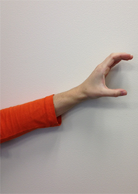 | 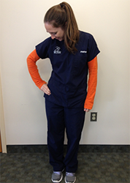
What is the treatment of FAI and labral tears?
The most appropriate initial treatment for all patients is to stop or modify the activity causing the hip pain. If this does not help, anti-inflammatory medications, physical therapy, chiropractic treatment, massage therapy, and/or selective injections can all be helpful in relieving the symptoms. If these methods fail to provide adequate relief or restore adequate function, then surgery is considered. When FAI was initially described by Dr. Ganz’s group in Switzerland in the mid-1990’s, they described treating this with a large incision to dislocate the hip to reshape the ball and/or the socket to correct the mechanical problem. Fortunately these days, in the hands of an experienced hip arthroscopist, the vast majority of these cases can be performed through two or three ½ inch incisions as an outpatient procedure.
Surgical Treatment: Dr. Wolff’s philosophy
Surgery should be the last resort. The human body has a tremendous capacity to heal itself or to make accommodations so that it can continue to function normally. When that is not the case, our goal as surgeons ought to be to restore the body and its anatomy to its most natural functional state. As most labral tears are caused by an abnormality of the bone and/or the soft tissue, it is important to not only address the labral tear, but also that which likely led it to tear.
Labral Tears: How to treat
As discussed above, the labrum is an important structure in most hips that provides for stability and management of the flow of vital joint fluid with keeps the joint healthy, nourished and lubricated. It should be preserved to the extent possible.
The labrum will sometimes tear in a peripheral location so that the main functional portion of it remains intact. This can be thought of an irritant akin to a hangnail that can be simply removed without interrupting the functional integrity of the remainder of the labrum. In my experience, these types of tears represent a small minority of all labral tears. Most tears are partial tears at the base of the labrum where it joins the bone and cartilage of the acetabulum and the stability of entire labrum in that region is compromised. It is in this much more common scenario where the labrum should be repaired to restore normal anatomy, function and durability of the hip for the long-term. This has been borne out by multiple studies that have shown approximately two-thirds of people doing well with labral debridements (removing portions of the labrum), while 90+% of patients do well with repair of the labrum.
See Dr. Wolff perform an arthroscopic hip labral repair (https://www.youtube.com/watch?v=BZT0R0AsPQ4)
How to Treat FAI (Hip Impingement)
In the majority of cases that require surgery, there is some amount of correction of the bone that should be performed to address the underlying cause of the hip pain and to protect any repair that is being performed. As discussed above, there are two type of impingement: cam and pincer. Check out these videos to see how these procedures are performed.
See Dr. Wolff perform an arthroscopic correction of cam type impingement (https://www.youtube.com/watch?v=C4iBFV3saQc)
See Dr. Wolff perform an arthroscopic correction of pincer type impingement with labral repair (https://www.youtube.com/watch?v=BZT0R0AsPQ4)
What is the Hip Capsule?
The hip capsule is a secondary supporting structure around the hip joint that helps to stabilize the joint and keeps the lubricating fluid in the joint. There are multiple ligaments which are confluent with the capsule to provide extra stability.
Problems with the Hip Capsule
In some patients the hip capsule is too lax or gets stretched out or torn due to injury or repetitive trauma. This can lead to instability of the hip that can cause pain and predispose the patient to labral tears and other problems with the hip joint.
How to Treat Hip Capsule Problems
The hip capsule can be repaired or tightened (plicated) arthroscopically. This will provide additional support and stability to the hip joint.
See Dr. Wolff perform an arthroscopic capsular plication (tightening) (https://www.youtube.com/watch?v=CudEQRnuLTA)
What to do when the labrum is deficient
There are many people who can have a well functioning hip joint in the absence of a labrum. Unfortunately, there are also many who cannot. This can be due to a labrum that has been previously debrided or a labrum which has been torn in an irreparable manner. In this circumstance, a reconstruction of the labrum can provide excellent return of function and elimination of pain.
See Dr. Wolff perform an arthroscopic labral reconstruction (https://www.youtube.com/watch?v=7qlKuxX0v50)

